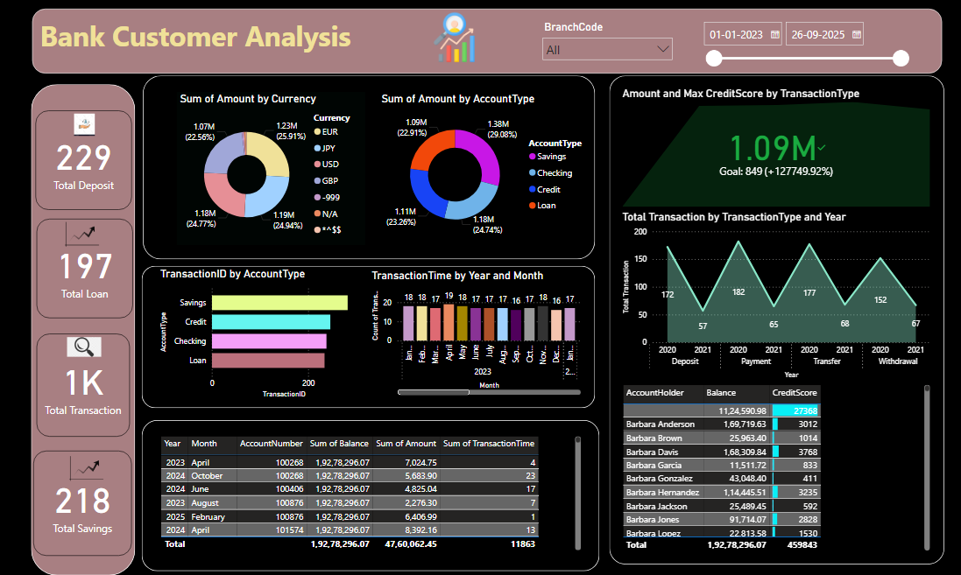

Banking Analysis: Power Bi Dashboard For Customer Details Of The Year 2023-25

# Introduction:

In the banking sector, the quality of customer service you deliver determines, to a large extent, whether or not the customer sticks with a bank. That’s because today’s bank customers expect fast, personalized, and consistent service across all platforms. A good example is when a customer applies for a loan online: quick responses and clear, customized guidance can greatly improve their overall banking experience. In this blog, we examine the customer details in the banking and finance sectors.

# Tools and Technique Used:

Ms Excel - Used to collecting and import the dataset into Power Bi.

Power Bi – It is used for visualizing the data meaningfully with different charts and graphs.

DAX - A DAX query is used to view data in the model. The main parts of DAX query: EVALUATE , which is required, that specifies what data you want to see. DEFINE , which is optional, that can specify a measure, or named DAX formula, to use in the DAX query.

# Dashboard Analysis:

These are the overall Analysis form the year 2023 -2025 and there are 499 Branches in this analysis,

**Account Type**: Under the Bank Customer Analysis There are Four Types of Account Savings, Credit, Loan, Checking. In this Highest Account type is Savings, and the lowest account type is Loan. Here I have mentioned Transaction-id also the first will be No: 282 and the least will be No: 232.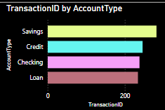

Here we have sum of account type which is 29.08% as savings, 24.74% as checking, 23.26% as credit and finally 22.91% as loan. For the overall 2023-2025

## overall

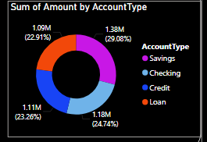

## 2023 2024 2025

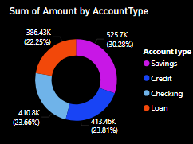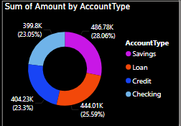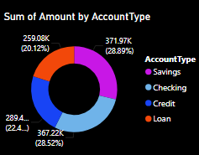

**Total Transaction**: Banking transactions have evolved significantly over time, shifting from simple deposits and withdrawals to complex digital transfers. Understanding this evolution provides insight into how bank transactions works. Here there are some the transaction type.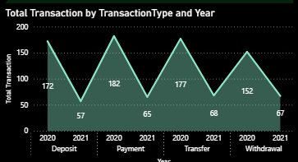

## 2023 2024 2025

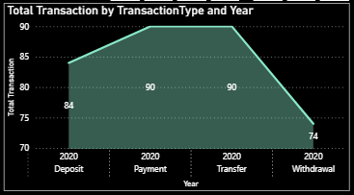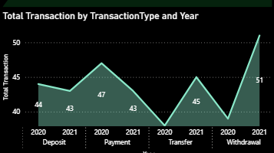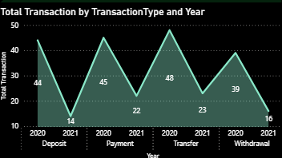

**Balance, Amount & Transaction Time**: In this we have segregated Year, Month, Account number, sum of balance , sum of amount and sum of transaction time.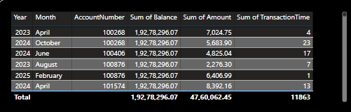

Amount by Currency: There are four types of currencies used here EUR, JPY, USD, GBP

EUR stands for “EURO”

JPY stands for “JAPANESE YEN”

USD stands for “UNITED STATES DOLLAR”

GBP stands for “BRITISH POUND STERLING”

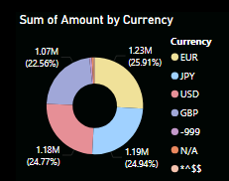

**KPI (Maximum Credit Score)**: KPI key performs credit score is based on your credit history, which includes information like the number of accounts, total debt levels, repayment history, and other factors. Lenders use credit scores to evaluate your creditworthiness or the likelihood that you will repay loans in a timely manner. Here there are amount and maximum credit score by transaction type

## overall 2024 2025

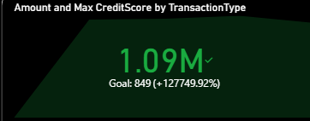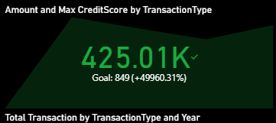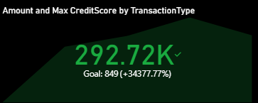

**Credit score**: A credit score is a prediction of your credit behavior, such as how likely you are to pay a loan back on time, based on information from credits reports, here 27368 is the highest credit score. Down there is complete details of account holder, tooltip for accountholder complete details are given.

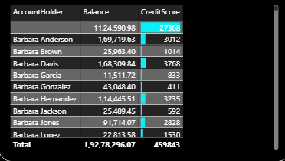 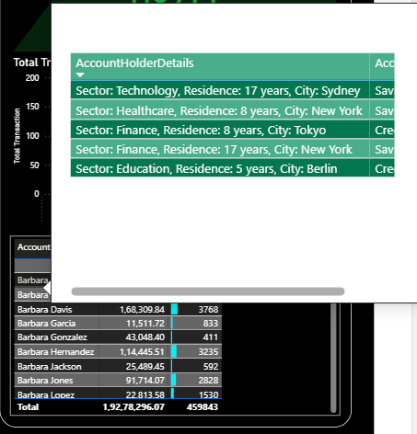

**2023 VIEW:**

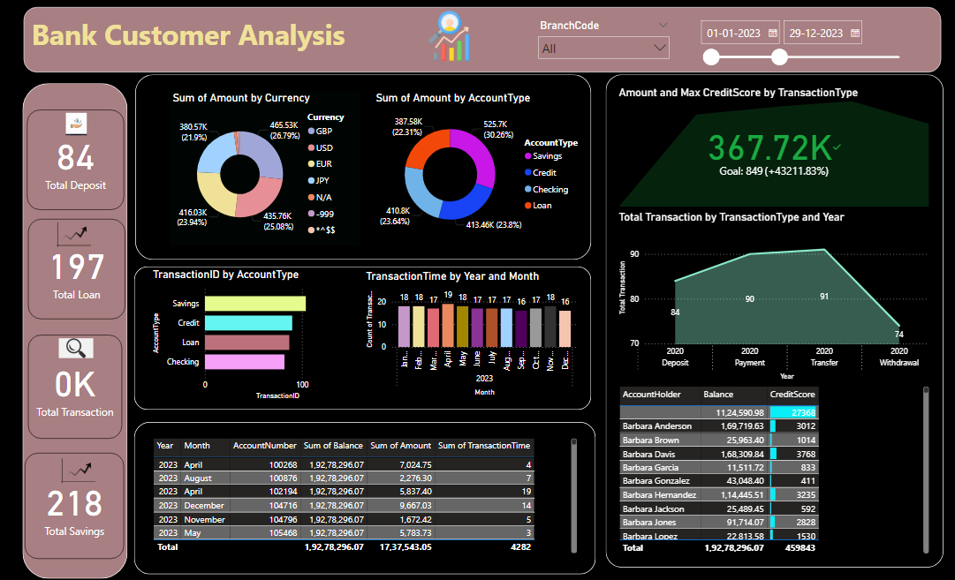

**2024 VIEW:**

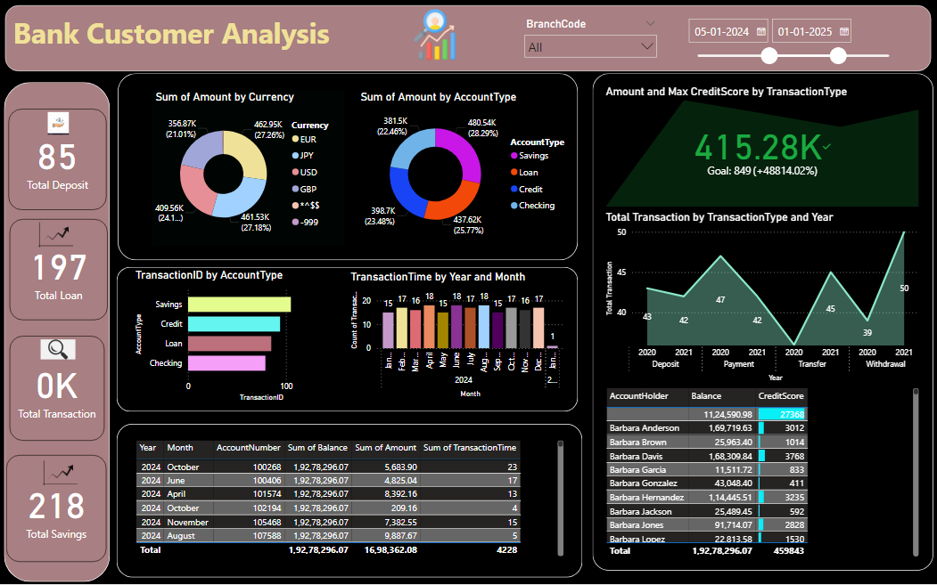

**Transaction by year**: Transaction banking is a term which covers a variety of different services helps clients to manage their cash inflows and outflows in an effective way, and provides them with short-term cash management options. There are some transaction year by year and the month.

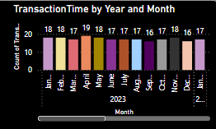

**Conclusion**: The complete observation comes under the conclusion that year by year transactions , savings and deposits are increasing gradually and various currency’s amount is also increasing so that we can increase customers. If it increases like this we can grow up to 30% by the next two years.